

**North South University**

**Department of Electrical and Computer Engineering**

**LAB REPORT-08**

**Course name: Digital Logic Design Lab**

**Course Code: 231.L**

**Experiment Number:** 07

**Experiment name:** Introduction to Multiplexers and Decoders

**Experiment Date:** 27th April, 2021

**Report Submission Date:** 27th April, 2021

**Section: 06**

**Group no: 04**

|  |  |
| --- | --- |
| **Student Name** | **ID** |
| Khalid Bin Shafiq | 1911342642 |
| Rafidul Islam | 1912152642 |
| Rashiqur Rahman Rifat | 1911445652 |
| Towsif Muhtadi Khan | 1911576642 |
| **Remarks:** | **Score:** |

Objectives:

* Gain a practical understanding of State Diagrams and State Tables.
* Understand the concept of designing Sequential Circuits using Flip-Flops.
* Design and implement a Synchronous Sequential Circuit given a State Diagram.

Theory:

**Synchronous Sequential Circuits:**

Sequential Circuit is made of combinational circuits and memory storage where circuits conduct the operation of present output based on present inputs and past outputs stored in memory storage. In a sequential circuit, the values of the outputs depend on the past behavior of the circuit, as well as the present values of its inputs. A sequential circuit has states, which in conjunction with the present values of inputs determine its behavior. Sequential circuits can be Synchronous where flip-flops are used to implement the states, and a clock signal is used to control the operation.

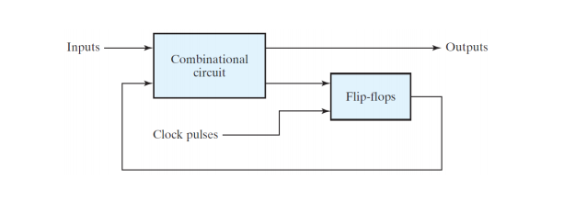

***Figure****: The general form of a synchronous sequential circuit.*

**State Table:**

The state table representation of a sequential circuit consists of three sections labeled present state, next state and output. The present state designates the state of flip-flops before the occurrence of a clock pulse. The next state shows the states of flip-flops after the clock pulse, and the output section lists the value of the output variables during the present state.

**State Diagram:**

In addition to graphical symbols, tables or equations, flip-flops can also be represented graphically by a state diagram. In this diagram, a state is represented by a circle, and the transition between states is indicated by directed lines (or arcs) connecting the circles.

Equipment List:

* Trainer board
* 1 x IC 74107 JK Flip-Flop
* 1 x IC 7408 2-input AND gates
* 1 x IC 7404 Hex inverters (NOT gates)
* IC 7474 (Dual D Flip-Flops)
* IC 74107 (Dual JK Flip-Flops)

Circuit Diagram:

***Figure D.1.1*** *4:1 Multiplexer*

***Figure 2.1****: 8:1 Multiplexer to implement a Boolean function*

***Figure 2.1****: 8:1 Multiplexer to implement a Boolean function*

***Figure 3.1****: Implementing a 3 to 8 Line Decoder*

KMAP :

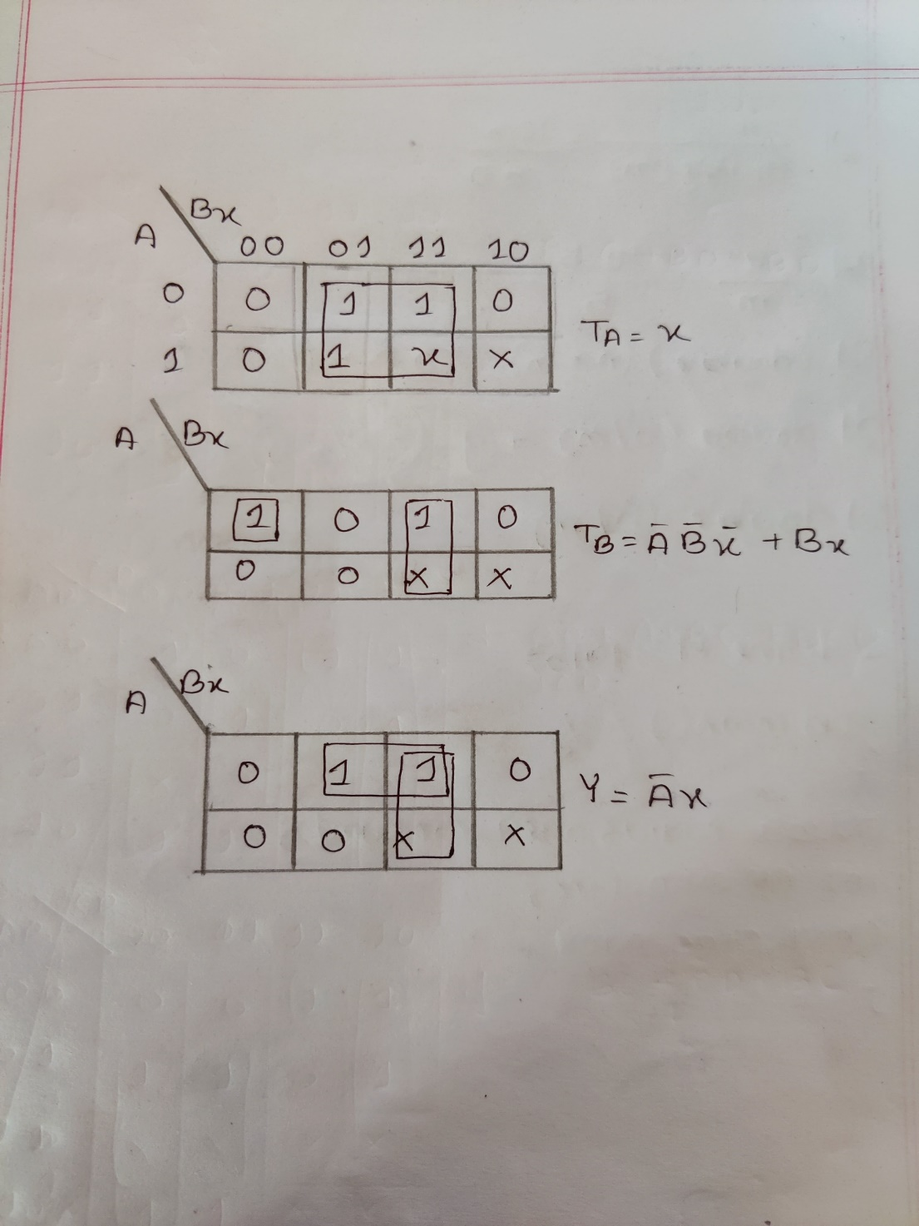

Data & Table:

|  |  |  |  |  |  |  |  |  |  |
| --- | --- | --- | --- | --- | --- | --- | --- | --- | --- |
| Present state | | Input | Next state | | Output | Flip-flop input functions | | | |
| A | **B** | **X** | **A** | **B** | **Y** | **JA** | **KA** | **JB** | **KB** |
| 0 | 0 | 0 | 0 | 1 | 0 | 0 | X | 1 | X |
| 0 | 0 | 1 | 1 | 0 | 1 | 1 | X | 0 | X |
| 0 | 1 | 0 | 0 | 1 | 0 | 0 | X | X | 0 |
| 0 | 1 | 1 | 1 | 0 | 1 | 1 | X | X | 1 |
| 1 | 0 | 0 | 1 | 0 | 0 | X | 0 | 0 | X |
| 1 | 0 | 1 | 0 | 0 | 0 | X | 1 | 0 | X |
| 1 | 1 | 0 | X | X | X | X | X | X | X |
| 1 | 1 | 1 | X | X | X | X | X | X | X |

***Table F.1.1****: State Table for circuit using JK Flip-Flops*

|  |  |  |  |  |  |  |  |
| --- | --- | --- | --- | --- | --- | --- | --- |
| Present state | | Input | Next state | | Output | Flip-flop input functions | |
| A | **B** | **X** | **A** | **B** | **Y** | **TA** | **TB** |
| 0 | 0 | 0 | 0 | 1 | 0 | 0 | 1 |
| 0 | 0 | 1 | 1 | 0 | 1 | 1 | 0 |
| 0 | 1 | 0 | 0 | 1 | 0 | 0 | 0 |
| 0 | 1 | 1 | 1 | 0 | 1 | 1 | 1 |
| 1 | 0 | 0 | 1 | 0 | 0 | 0 | 0 |
| 1 | 0 | 1 | 0 | 0 | 0 | 1 | 0 |
| 1 | 1 | 0 | X | X | X | X | X |
| 1 | 1 | 1 | X | X | X | X | X |

***Table F.2.1***: *Constructing a Sequential Circuit using T Flip-Flops*

|  |  |  |  |  |  |  |  |
| --- | --- | --- | --- | --- | --- | --- | --- |
| Present state | | Input | Next state | | Output | Flip-flop input functions | |
| A | **B** | **X** | **A** | **B** | **Y** | **DA** | **DB** |
| 0 | 0 | 0 | 0 | 1 | 0 | 0 | 1 |
| 0 | 0 | 1 | 1 | 0 | 1 | 1 | 0 |
| 0 | 1 | 0 | 0 | 1 | 0 | 0 | 1 |
| 0 | 1 | 1 | 1 | 0 | 1 | 1 | 0 |
| 1 | 0 | 0 | 1 | 0 | 0 | 1 | 0 |
| 1 | 0 | 1 | 0 | 0 | 0 | 0 | 0 |
| 1 | 1 | 0 | X | X | X | X | X |
| 1 | 1 | 1 | X | X | X | X | X |

***Table F.3.1:*** *State Table for circuit using D Flip-Flops*

*F.3.1: 3 to 8 Line Decoder*

Questions:

**Ques-01: Is the output equation (Y) of this circuit the same as the equation in the JK Flip-Flop circuit? Explain why.**

ANS:

From given state diagram, the obtained output values of y depend on the flip-flop output and external input for both JK flip-flop and T flip-flop. As the values of external output y is same for JK flip-flop and T flip-flop, the output equation obtained from k-map will also be same.

Result analysis and Discussion:

The overall lab experiment was about the implementation of synchronous sequential circuit using different types of flip-flops. At the beginning of the experiment,we implemented the synchronous sequential circuit using JK flip-flop.

At first, from given state diagram, we had to complete the state table with next state values and external output values. Then using Karnaugh map built from state table, we got required state equations. Using these state equations, we constructed the sequential circuit.

Then we constructed synchronous sequential circuit using D flip-flop and T flip-flop as same as did for JK flip-flop. Additionally, we did the implementation with basic logic gate ICs and T flip-flop. During experiment, Logisim worked properly. Above all, from the experiment, we learned how to implement the synchronous sequential circuit using JK, D, T flip-flops.

Contribution

|  |  |
| --- | --- |
| Name | Contribution in |
| Khalid Bin Shafiq | Result Analysis and Discussion |
| Rafidul Islam | Circuit Diagram |
| Rashiqur Rahman Rifat | Theory |
| Towsif Muhtadi Khan | Data & table, Coordinator |